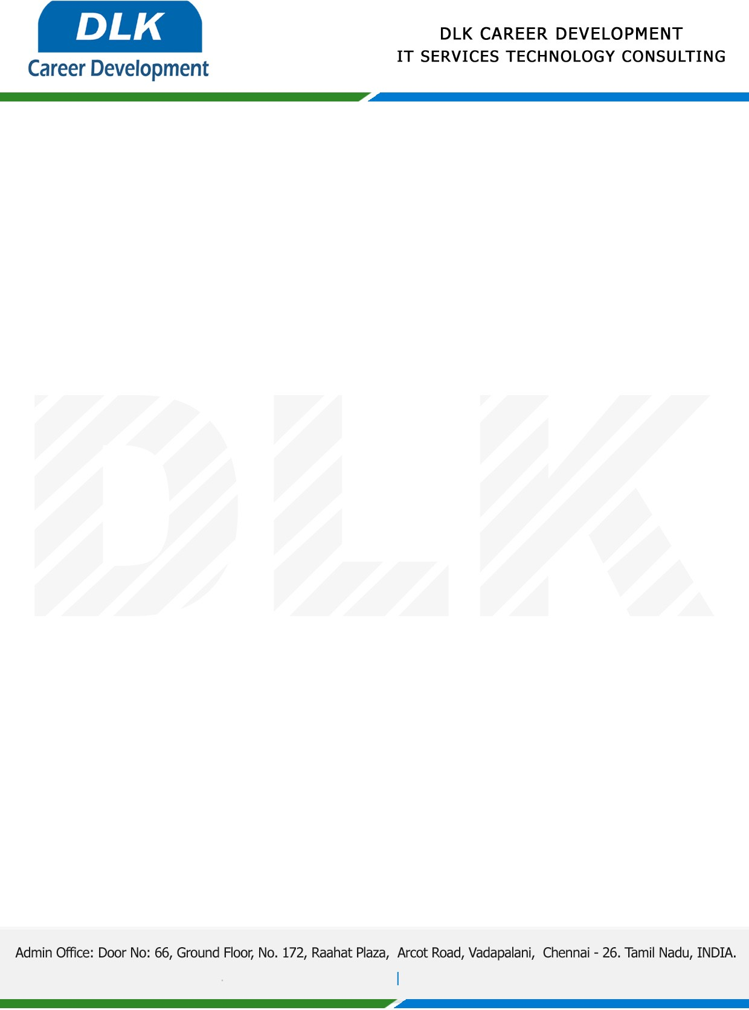

Date: 25 /February/ 2023

**To**

Department of MBA-Business Analytics

Head of Department,

SRM Institute of Science and Technology

**Sub: Letter of Project Acceptance**

This is to certify that **MR VARKUMAR V** **(REG NO:** **RA2152007010024)** final year student of has accepted the Project Work duration from **25th February 2023 to 20th April 2023** under the domain **“Python”.** During the Project, all information and data collected from you should be kept confidential.

**Topic**: Weather Forecasting using Machine Learning Algorithms

We appreciate your interest in **DLK CAREER DEVELOPMENT**

